**Out-Bounding Application Setup Document**

1. **prerequisites to set up a new ETL in an outbound application**

* To set up a new ETL in an outbound application first you need to extract the Bi Report to the given report path.
* Once the extraction is done, Run that report and export it into XML File.

(This XML File will be used to do mapping with the PaaS table)

* Create/Update the PaaS table as per the XML tags.

1. **Steps to set up a new Scheduler**

* To set up a new Scheduler you have to open the General Setup page of the Outbound Application

Have a look at the Below Snapshot of General Set up page.

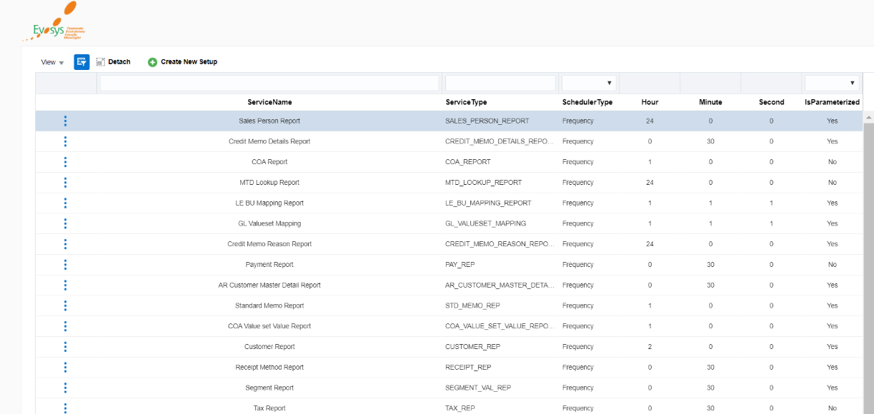

From this page, Users can create a new Scheduler or they can also update the existing one.

* If you want to create a new Scheduler then Click on **Create New Setup** button.

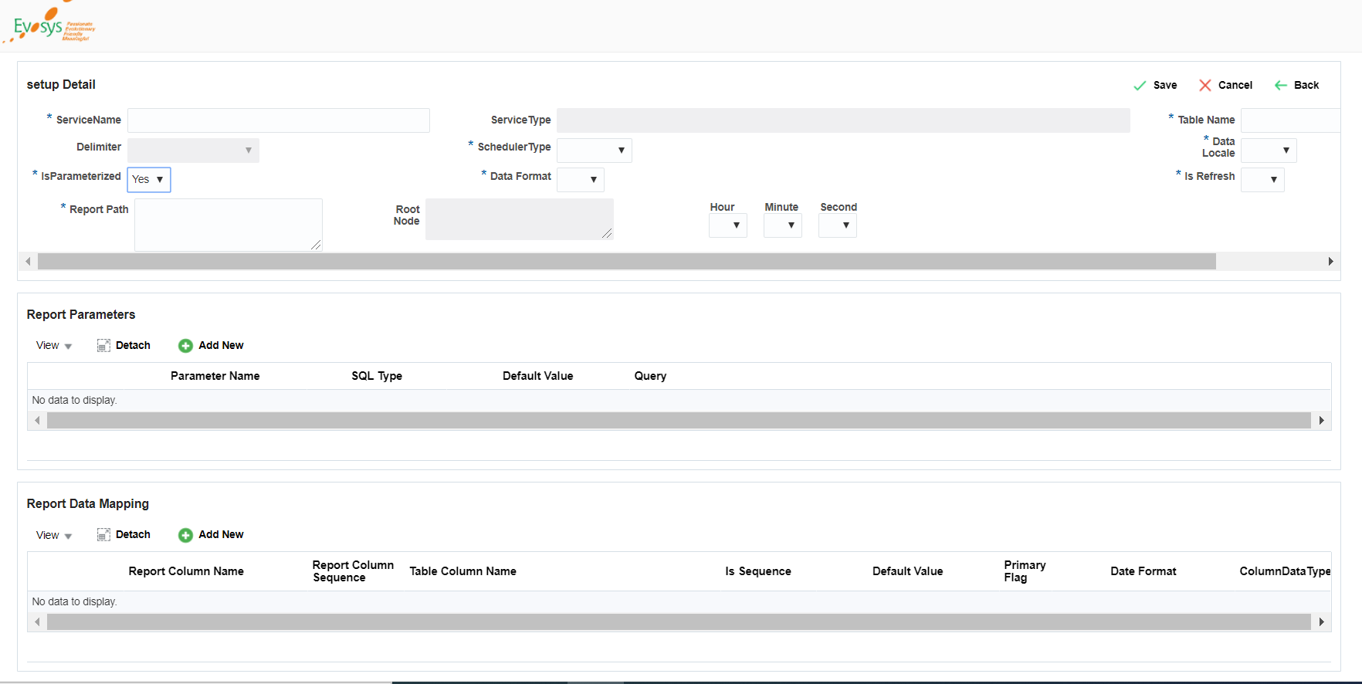

This will be your Interface to create a new Scheduler.

There are three Section in which you have to fill the data to create a Scheduler

* **Setup Details:**

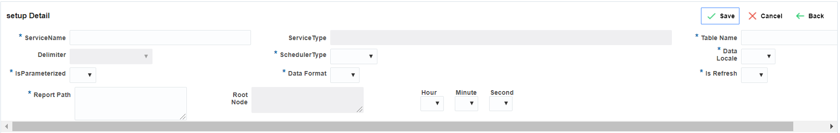

* **Service Name:** This filed contains the name of the scheduler.
* **Service Type:** This filed contains the unique name of the scheduler. The System will automatically generate Service Type name based on the Service name.  
  Note that you will not be able to modify the Service Type once it was generated.
* **Table Name:** Here you need to map the PaaS table in which report data will be stored.
* **Scheduler Type**: Scheduler type is either **Frequency Based** or **Time Based.**
* **Is Parameterized:**  Set to “Yes” If your reports require any parameter to be called.

For Example: From Date and To Date

If you set this field to ‘yes’ then Report Parameters Section will be enable.

* **Data Format:** Data format is either XML or CSV.

Data format must be in the XML Format otherwise you will get unexpected behavior.

* **Is Refresh:** If you have set this field to **Yes,** It always delete the record first and then going to insert the records.
* **Report Path:** Here you need to define the report path from where your report will be called.

For Example: /Custom/PAAS/Reports/BCC Custom Reports/BCC AR Standing Charge Invoice Report.xdo

* **Root Node:** If you have selected XML as Data format then you will have to provide the Root node of the XML.
* **Hour/Minute/Second:** At which Time/Frequency you want to run the Scheduler.

**Report Header Data will be Stored in SC_SCHEDULER_SETUP and SC_REPORT_SETUP_HEADER table.**

* **Report Parameters:**

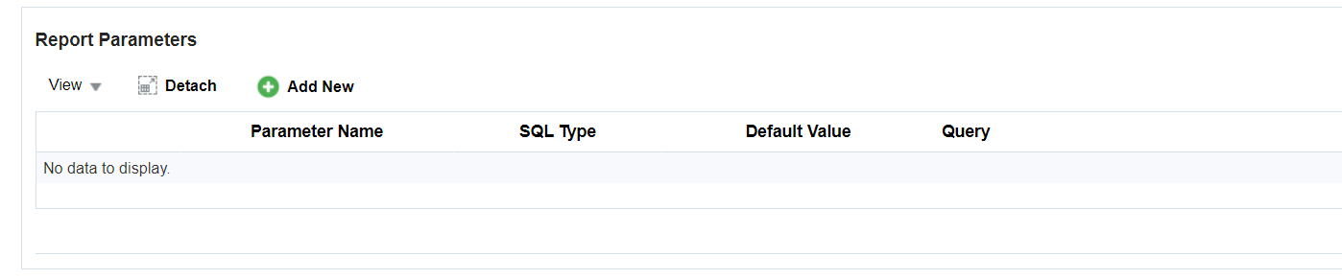

If you have set **Is Parameterized** parameter in **Setup Detail** Section to **yes** then this section will be enable.

From this section you can add the report parameters which are used as an input value to call the report.

To Add Parameters Click on **Add New** button

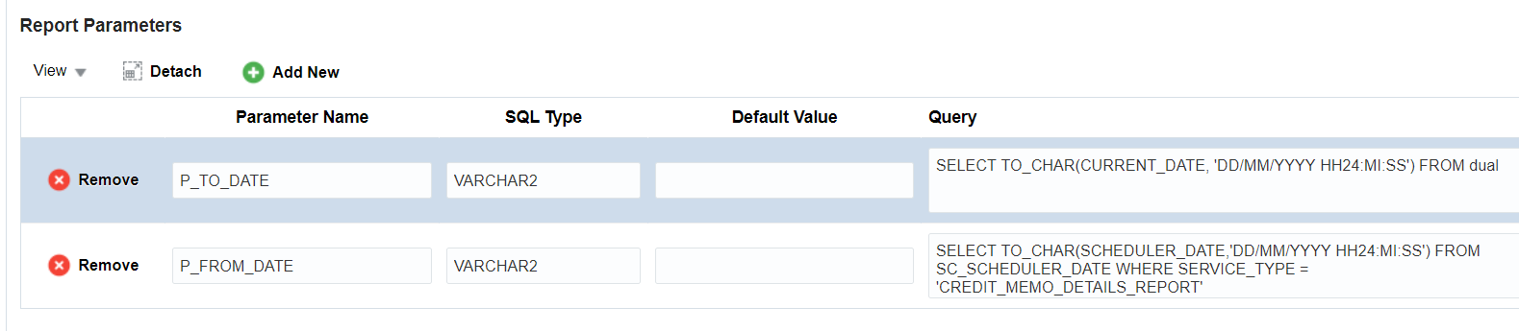

* **Parameter Name:** Name of the parameter mentioned in the report data model.
* **SQL Type:** SQL type of that parameter.
* **Default Value:** If you want to pass any default value to that field then you have to provide it here.
* **Query:** SQL Query to fetch the data from the DB (Refer the above Snapshot).

**Report Parameters Data will be stored In SC_REPORT_SETUP_DTL table.**

* **Report Data mapping:**

This section is used to map report columns to the Database table.

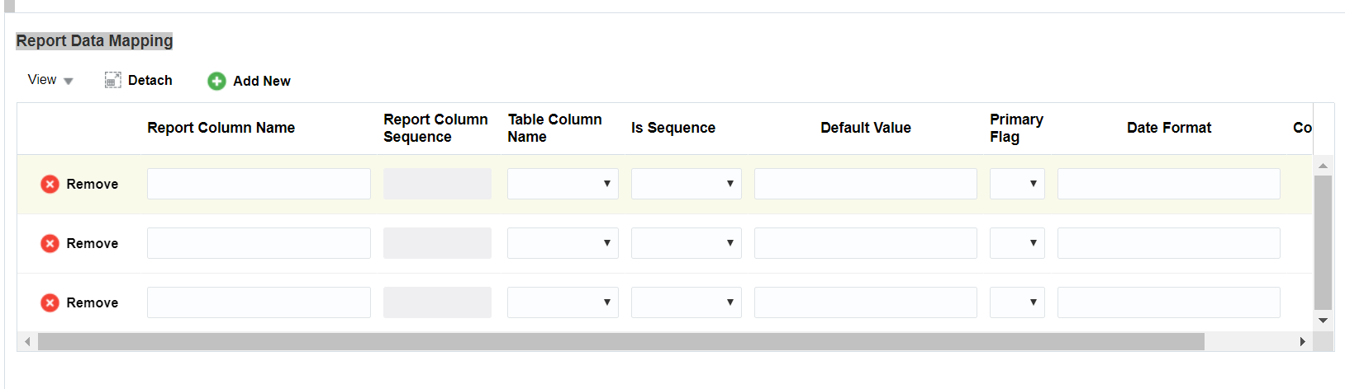

The Downloaded file in the prerequisites step will be used here when you mapped the data in this section.

Have a look at the Snapshot of the downloaded XML File.

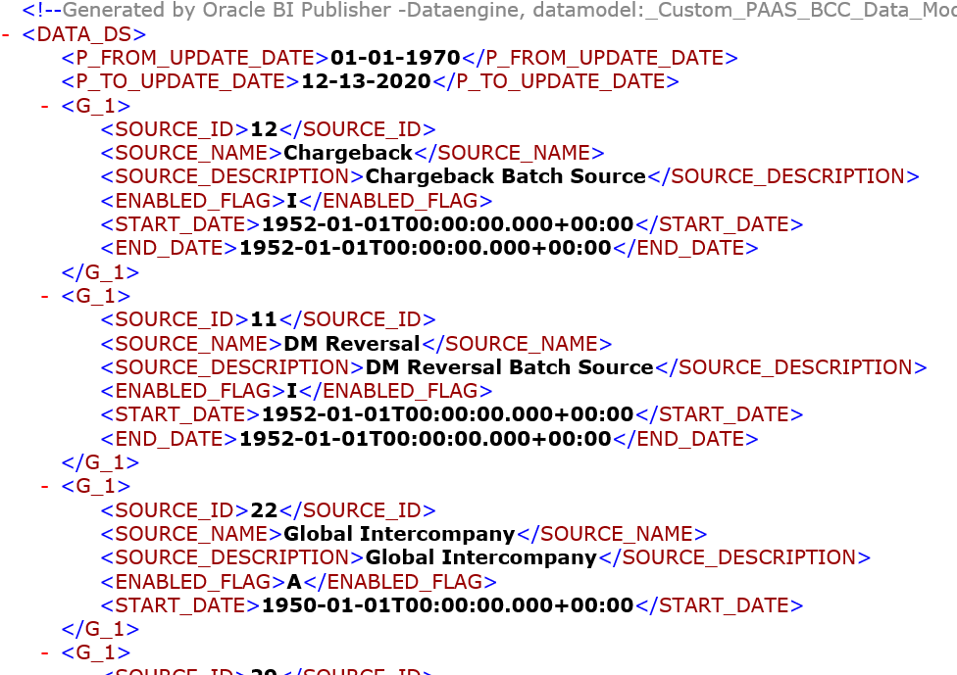

Where the **Data_DS/G_1** is the root node of the XML File and **P_FROM_UPDATE_DATE** and **P_TO_UPDATE_DATE** is the parameter you have passed on the **Report parameters** section.

**Please find the Example below:**

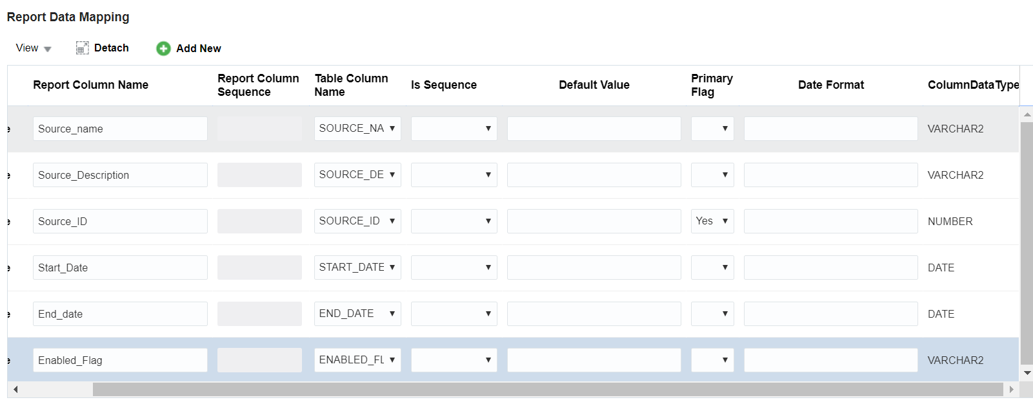

**Report Column Name:** This field contains the Column name of the report. You can find the report column name from the XML file.

For Example:

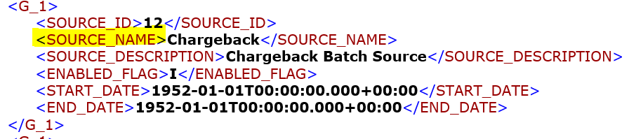

**Table Column Name:** This field contains the column name of the database table where you want to map report column data.

**Is Sequence:** This field is set to **yes** if your column contains DB Sequence.

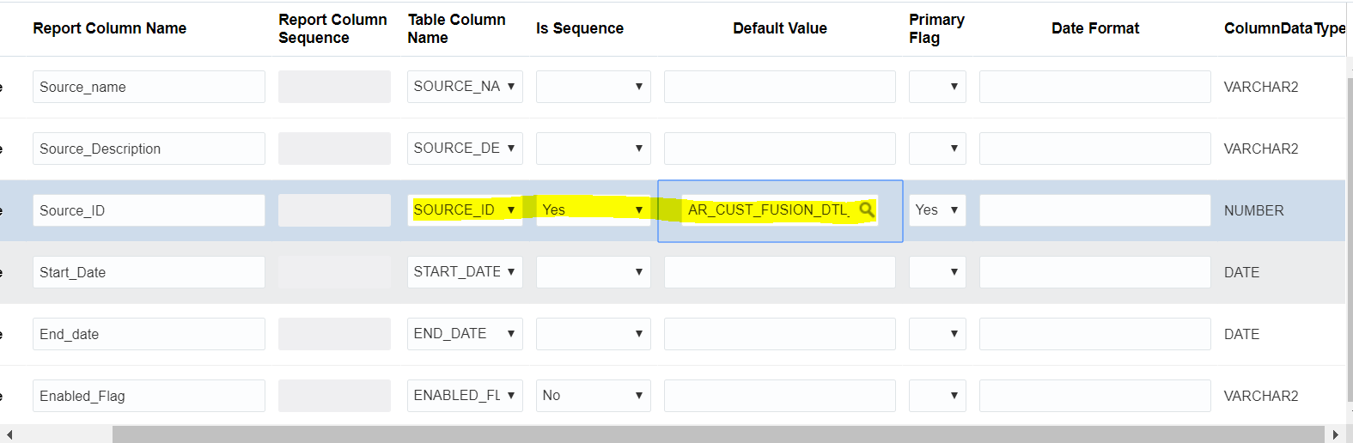

If you have selected this field to **Yes,** you have to provide sequence name as default value.

**Primary Flag:**  Primary flag is work as a **where clause** in the update statement. If you have selected primary flag as **Yes**then when the duplicate data comes, it will automatically update the row based on the primary flag.

**Date Format:**  Date Format is used to specify the particular format of the date.

**Column Data Type:** It defines the data type of the column.

**Report Mapping Data will be stored in the SC_REPORT_DATA_MAPPING table.**

**You can check the LAST_RUN_DATE of the Scheduler from the SC_SCHEDULER_DATE table.**

**Once the set-up is done click on the save button to save the configuration.**

1. **Run the Scheduler:**

To run the created Scheduler, You have to go to the **Scheduler page**.

This will be your user interface of the Scheduler page.

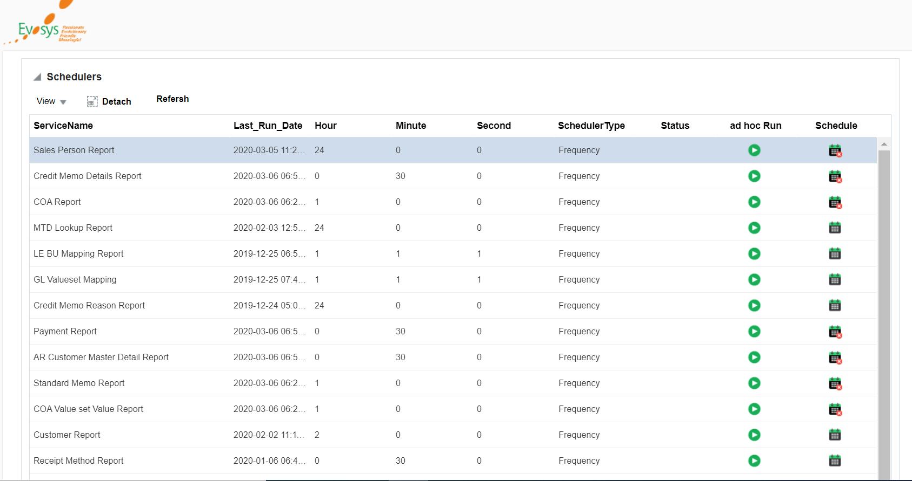

From this page you can start/stop the Scheduler by clicking on the Scheduler Icon (Column name = Scheduler), or you can run immediately by click on the ad-hoc button of the Scheduler.

**Report run history data will be stored in SC_REPORT_RUN_HISTORY table.**